STUDENT GRADE MANAGEMENT SYSTEM

1. Define a function calculate_average(marks) that:
Accepts a list of 5 numeric marks (between 0 and 100).
- Returns the average of these marks.

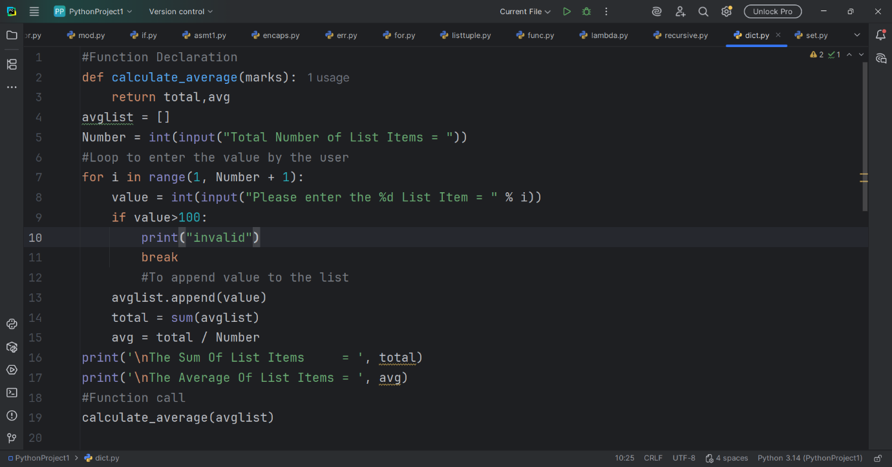

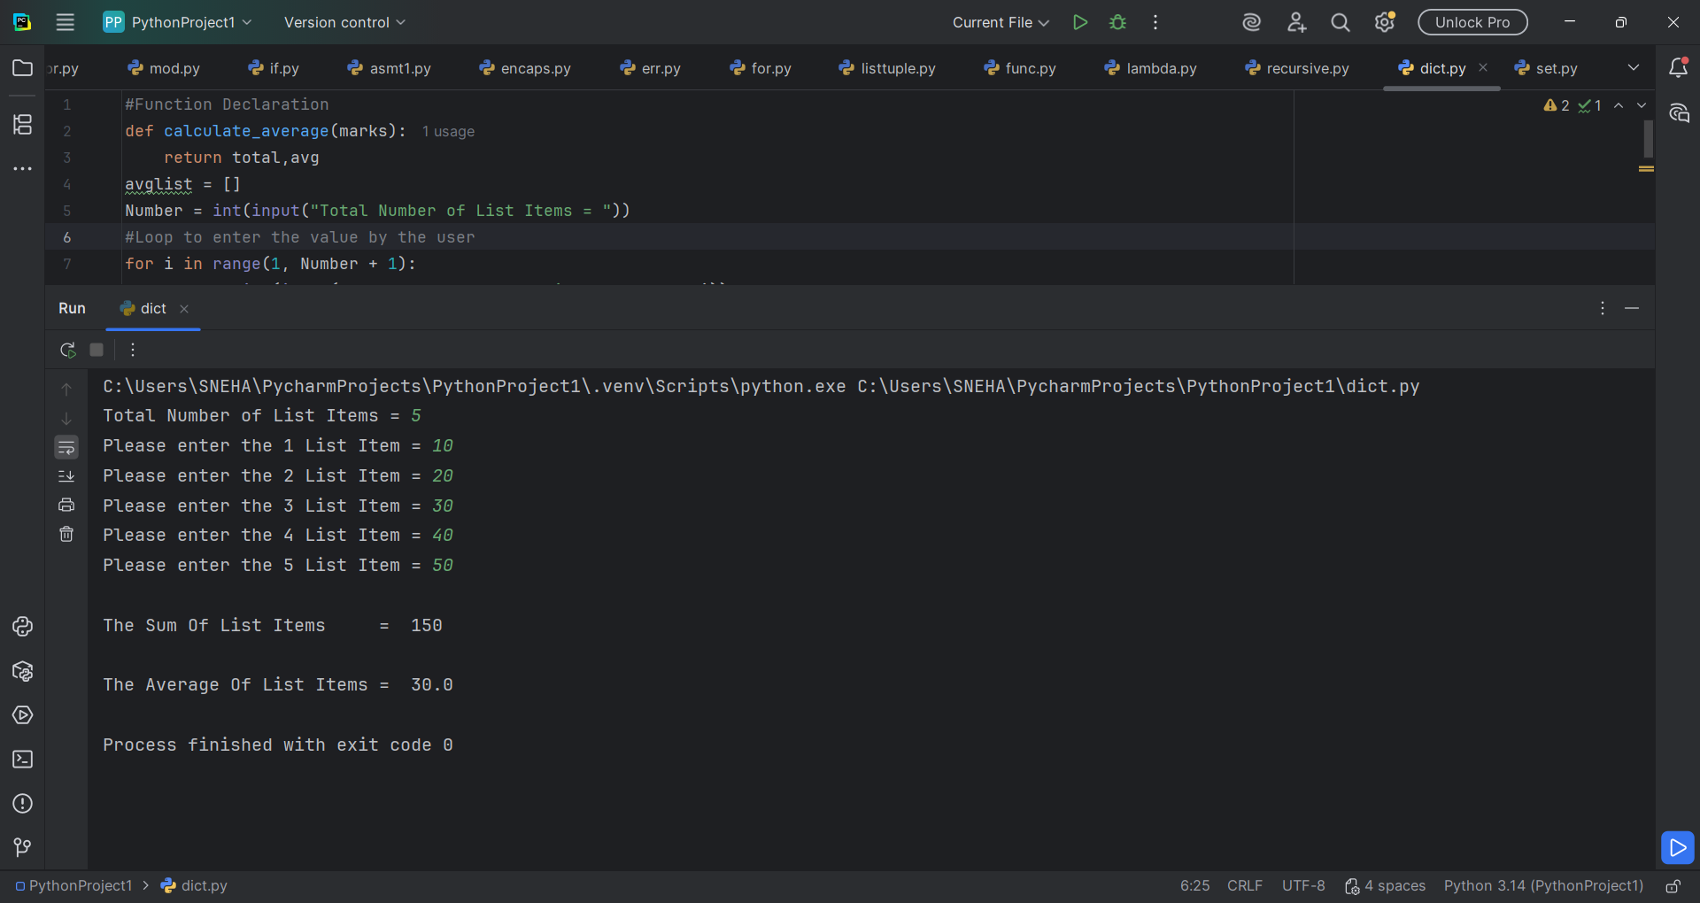

2. Define another function get_grade(average) that:
- Accepts the average mark as input.
- Returns the grade based on the criteria
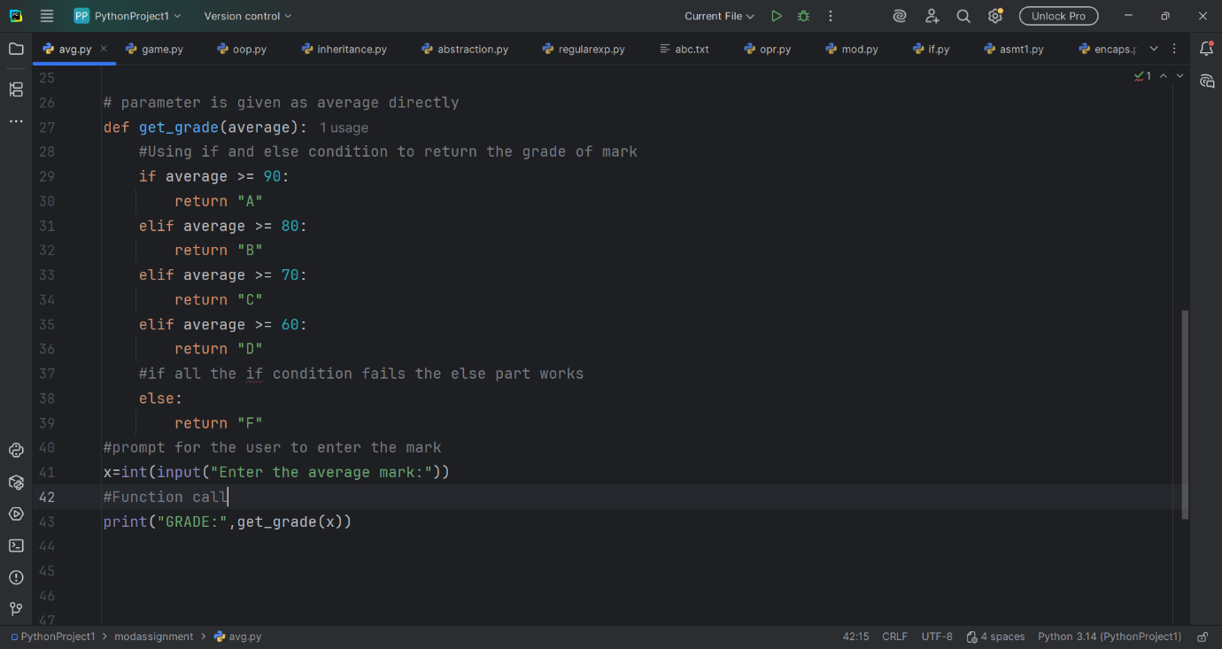

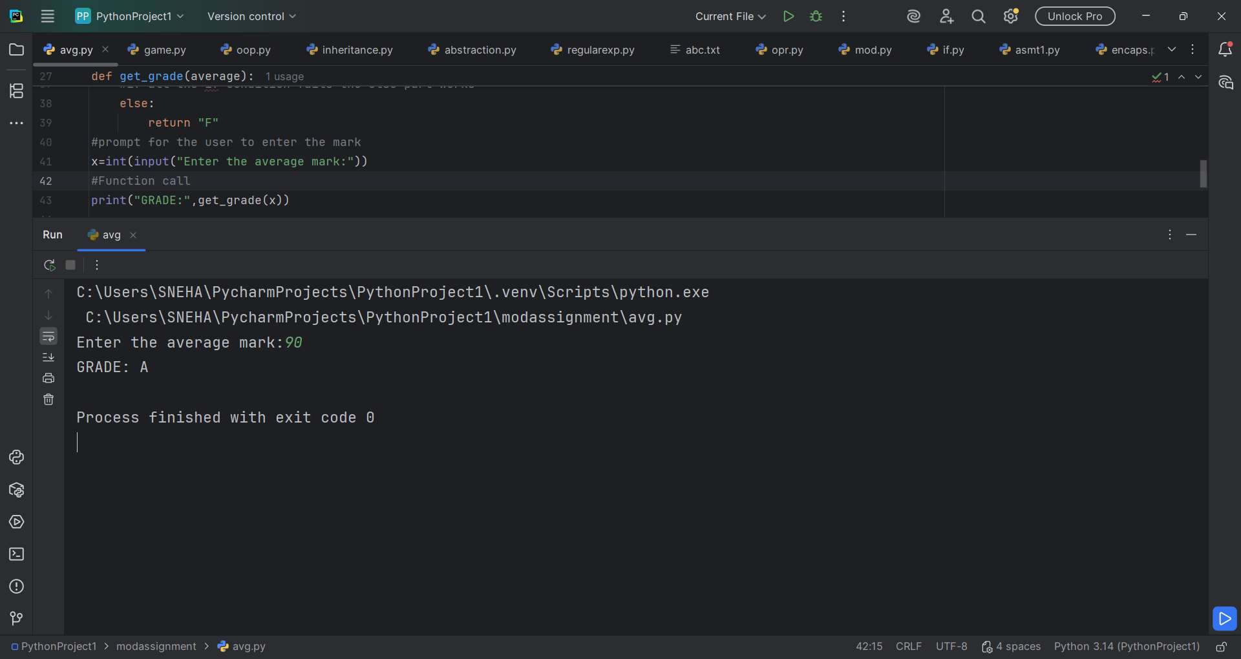

3. In the main program:
- Prompt the user to enter marks for 5 subjects.
- Validate that each mark is a number between 0 and 100.
- Use the defined functions to calculate the average and determine the grade.
- Display both the average and the final grade.

